A Mini Project Final Report on

**Web Based Crime Report and Analysis System Using PHP and Mysql**

Submitted in Partial Fulfillment of the Requirements for

the Degree of

**Bachelor of Engineering in Information Technology**

Under Pokhara University

**Submitted by:**

**Deepak Sapkota,171547**

**Arun Shrestha,171546**

Date:

**10thJanaury 2020**



**Department of Information Technology**

**NEPAL COLLEGE OF**

**INFORMATION TECHNOLOGY**

**Balkumari,Lalitpur,Nepal**

#### ACKNOWLEDGEMENT

We would like to express our sincere gratitude to our supervisor Dr. Roshan Chitrakar for providing his valuable guidance,comments and suggestions throughout the course of the project. On the submission of our first project report on “Web Based Crime Report And Analysis System”,We would like to extend our sincere thanks to all individuals for their constant motivation and support during the course of our work throughout the semester. We truly appreciate and value esteemed guidance and encouragement from the beginning to the end of this project.

Above all,we would also like to thanks our friends who helped us directly and indirectly for the completion of our project. It would have been impossible without their moral support.

#### ABSTRACT

This project’s main idea is to implement an online web application for maintaining the common people complaints for police department. By using this application, people who are afraid or don’t have enough time to go police station for complaint about their personal legal issues, here they can register their complaints online. Here, users will have the awareness about laws and the respective punishments for the crime activities. First, people have to register their personal details along with login details using registration form. Once he/she registers in the application, they can post their complaints. Several reasons may contribute to this lack of reporting. Also Crime reporting needs to be possible at anytime. Although several other options exist and there are most publicized reporting mechanisms. Internet-based crime reporting systems allow victims and witnesses of crime to report incidents to police 24/7 from any location. The aim of this project is to develop an online crime report and managing system which is easily accessible to the public, police department and the administrative department. The system is intended for use in a community to help the residents interact with each other more easily and to encourage the reporting of suspicious behavior or crime. This system registers the complaints from people through online and it will also helpful to police department in catching criminals, in system and person can give any complaint at any time.

**Keywords**: *crime, register, complaints, awareness, punishments, reporting* .

#### Table of Content

ACKNOWLEDGEMENT I

ABSTRACT II

Table of Content III

LIST OF FIGURES 1

LIST OF TABLES 2

1 INTRODUCTION 3

1.1 INTRODUCTION TO PHP 3

1.2 Common uses of PHP 2

1.3 Introduction Of Mysql Database 2

1.3.1 Over-View of Mysql Database 2

2 Literature Review 3

2.1 RELATED WORKS 3

2.2 Existing System 3

2.3 Disadvantages Of Existing System 4

3 PROBLEM STATEMENTS 5

3.1 PROBLEM OBJECTIVES 5

4 SCOPE AND IMPORTANCE OF THE PROJECT 6

5 METHODOLOGY 7

5.1 SOFTWARE DEVELOPMENT LIFECYCLE 7

5.1.1 ANALYSIS PHASE 8

5.1.2 DESIGN PHASE 8

5.1.3 CODING PHASE 8

5.1.4 TESTING PHASE 8

5.3 Use Case Diagram 9

6 PERFORMANCE ANALYSIS AND VALIDATION SCHEME 10

6.1 PERFORMANCE ANALYSIS METHODOLOGY 10

6.2 VALIDATION SCHEME 10

7 WORKING SCHEDULE 11

7.1 TIME SCHEDULE 11

8 CONCLUSION 12

9 FUTURE WORKS/RECOMMENDATIONS 13

REFERENCES 14

#### LIST OF FIGURES

Fig 1: Mysql System Database

Fig 2: Incremental Model

Fig 3: Usecase Diagram

#### LIST OF TABLES

Table 1: Software Tools used

Table 2: Time Estimation Table

#### 1 INTRODUCTION

The “Web Based Crime Report and Analysis System” In PHP is a simple mini project for reporting complaints of any crimes. The project contains Admin,Sub-Admin and the User’s Section separately. The aim of this project is to develop an online crime report and managing system which is easily accessible to the public,The police department and the administrative department .We’ll be using HTML,CSS,Bootstrap, JavaScript as frontend and PHP and MySQL Server as backend easing the effort of user.

This system registers the complaints from people through online and it will also be helpful to police department in catching criminals.

1.1 INTRODUCTION TO PHP

PHP started out as a small open source project that evolved as more and more people found out how useful it was. Rasmus Lerdorf published the first version of PHP way back in 1994

1 PHP is a recursive acronym for “PHP: Hypertext Preprocessor”.

2

PHP is a server side scripting language that is embedded in HTML. It is used to manage dynamic content, databases, session tracking, even build entire e-commerce sites.

3 It is integrated with a number of popular database, including MYSQL, PostgreSQL, Oracle, and Microsoft SQL server.

4 PHP is pleasingly zippy in its execution, especially when once started, executed even very complex queries with huge result sets in record-setting time.

5 PHP is for giving: PHP language tries to be as forgiving as possible.

1.2 Common uses of PHP

1 PHP performs system functions, i.e. from files on a system it can create, open, read, write, and close them.

2 PHP can handle forms, i.e. gather data from files, save data to file, through email you can send data, return data to the users.

3 You add, delete, modify elements within your database through PHP.

4 Access cookies variables and set cookies.

5 Using PHP, you can restrict users to access some pages of your websites. It can encrypt data.

**1.3 Introduction Of Mysql Database**

MYSQl is a fast easy-to-use RDBMS being used for many small and big business. MYSQL is becoming popular because

1. MySQL is released under an open-source license.
2. MySQL is a very powerful program in its own right. It handles a large subset of the functionality of the most expensive and powerful database packages.
3. MySQL uses a standard form of the well-known SQL data language.
4. MySQL is very friendly to PHP, the most appreciated language for web development.
5. MySQL is customizable.

1.3.1 Over-View of Mysql Database

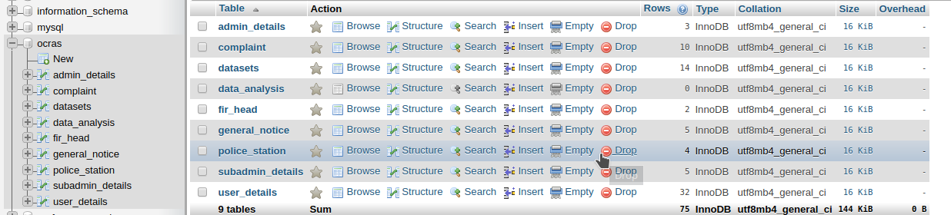

Fig 1 : Mysqli System Database

2 Literature Review

The word Crime originated from the Latin word Crimen dubbed charge or offence .According a research we Found that United States of America has a common database for reporting crime incidences which has improved policing in the US.Crime Report system was designed or implemented for the purpose of reporting committed crimes, but in the proposed system in addition to reporting committed crimes .

2.1 RELATED WORKS

There is a massive number of research work from journals, news papers, text, videos, and other documents available on the internet, on above any subject. police station need to be able to find information about people who commit crimes to satisfy people’s needs and also uses are able to report different crimes committed by different, individuals.

Therefore, online crime reporting system falls under information retrieval systems as it is also an information system in that, it helps people to simply report the crime online without going to the police station.

According to Bohan (2006), online crime reporting system is a prime example of modern day technology designed to make the world a superior place to live. When used properly this technology will not only enhance a human’s environment when it comes to convenience, but will also significantly enhance the safety of our community at a reasonable expense.

2.2 Existing System

Existing online crime reporting & analysis system does not have such medium by users can place their complain from any location. They have to visit their nearest police location and take a copy of the complaint for future reference. Many citizens hesitate to visit any police station and thus informer information cannot be kept confidential. Sometimes conflicts occurs between police station regarding area, means which area comes under their police station and the person get frustrated before placing their complains. If any citizen is sufferer of crime, even after dialing emergency number, police person do not able to locate the exact location of that citizen.

In this current system, user’s information will be kept confidential and only users complain will be forwarded to its nearest police station. Users complain number will be forwarded from the server side automatically.

1. It stores only the current status of criminals like number of cases.

2. Existing applications manages the data and various information about the criminals and their crimes.

3. In present manual system the total process of criminal report generation is not so fast and friendly . To solve this kind of problem proposed an better and automated system.

2.3 Disadvantages Of Existing System

In the existing system only our can see the details of particular information about the police stations in our state, the existing system has more workload for the authorized person. some drawbacks written below.

1. 1 More man power.
2. 2 Time consuming.
3. 3 Consumers large volume of pare work.
4. 4 Needs manual calculations.
5. 5 No direct role for the higher officials.
6. 6 Damage of machines due to lack of attention.
7. 7 The size of the database increases day-by-day, increasing the load on the database.
8. 8 At present there is no back up and data maintenance activity.
9. 9 Training for simple computer operations is necessary for the users working on the system.

#### 3 PROBLEM STATEMENTS

It is obviously believed that the police force is charged with the responsibility of protecting lives and property and assuring safety and well-being of all citizens through the detection and apprehension of criminals, prevention and control of crime.

Here are some of the problem statements that we have considered for the project.

1. More man power.
2. Time consuming.
3. Consumers large volume of pare work.
4. Needs manual calculations.
5. No direct role for the higher officials.
6. Damage of machines due to lack of attention.
7. The size of the database increases day-by-day, increasing the load on the database.
8. At present,there is no back up and data maintenance activity.
9. Training for simple computer operations is necessary for the users working on the system.

3.1 PROBLEM OBJECTIVES

Our project “Crime Report and Analysis System” has certain objectives. The project entitled as “Crime Report and Analysis System” is a web based application. It will be very useful for police department as well as common peoples. This software provides facility for reporting online crimes, complaints, missing persons and show related sections. This software is developed with scalability in mind. Additional modules can be easily added when necessary.

#### 4 SCOPE AND IMPORTANCE OF THE PROJECT

The scope for the system can be as follows:

1. 1 This will help the police department to manage their records easily.
2. 2 There is no need for a user to go to the police station to file any complaint.
3. 3 To provide a secure system to users.
4. 4 Complaint registration.
5. 5 Online first system.
6. 6 Giving feedback.
7. 7 Reduction of workload.
8. 8 Security

#### 5 METHODOLOGY

We have planned to work following these methodologies for the application of knowledge, skills, tools and techniques to a broad range of activities in order to meet the requirements of our project, “Web Based Crime Report and Analysis System”.

5.1 SOFTWARE DEVELOPMENT LIFECYCLE

The framework we will be using for developing this project is Incremental model. This model combines linear sequential model with the iterative prototype model. New functionalities will be added as each increment is developed. The phases of the linear sequential model are: Analysis, Design, Coding and Testing. The software repeatedly passes through these phase in iteration and an increment is delivered with progressive changes.

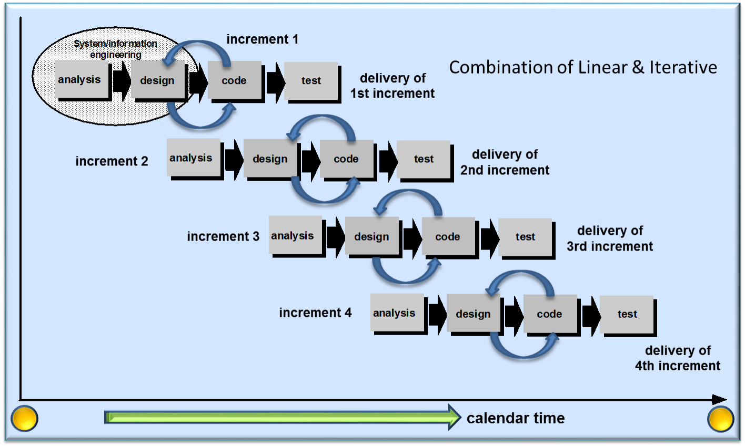

**Figure 1. Incremental Model**

**5.1.1 ANALYSIS PHASE**

In this phase, analysis will be performed to find out the requirements of the system. The outcome of this phase would be a SRS which is an acronym for “System RequirementSpecification”.

**5.1.2 DESIGN PHASE**

In this phase, the SRS would be translated into the system’s design. Context Diagram, DFD, ER – Diagram, Use Case Diagram and Class Diagram will be developed.

**5.1.3 CODING PHASE**

In this phase, coding will be done according to the design and a working system will be developed by the end of this process.

**5.1.4 TESTING PHASE**

In this phase, the system will be tested. With each testing, a list of changes to the system developed, is suggested and the changes will be applied to the software and the software would be delivered as a successive increment until a satisfying system is achieved.

**5.2 TOOLS USED**

The tools used for documentation, designing and developing UI/UX, testing is listed below in table.

|  |  |
| --- | --- |
| **Tools and Technologies** | **Purpose** |
| HTML, CSS , JavaScript | For web Frontend develop & Design |
| PHP, MySQL | For web application development |
| Sublime Text , VS Code | Sublime Text/ Visual Studio Code |
| XAMPP , LAMPP | For local Server and Database |
| FireFox , Brave | For Live Test Purpose |

Table 1: Software Tools used

5.3 Use Case Diagram

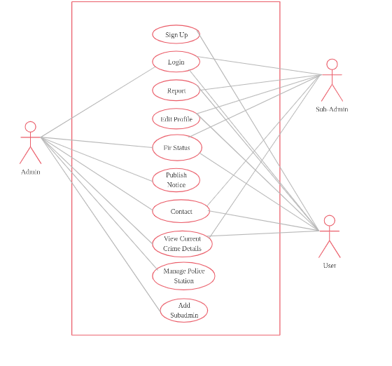

Fig 2 : Use Case Diagram

#### 6 PERFORMANCE ANALYSIS AND VALIDATION SCHEME

In this section, the performance analysis and validation scheme of the project are discussed.

6.1 PERFORMANCE ANALYSIS METHODOLOGY

Performance Analysis methodology of the project uses performance review in which bi-weekly reviews of the meetings are held to assess project status and variances are detected and addressed quickly.

6.2 VALIDATION SCHEME

Cross validation is used as the validation scheme of the project. Cross validation, sometimes called rotation estimation, is a model validation technique for assessing how the results of a statistical analysis will generalize to an independent data set.

#### 7 WORKING SCHEDULE

7.1 TIME SCHEDULE

The project schedule has been designed as per requirements and constraints involved. This project is scheduled to be completed in about 4 months. Requirement analysis have been given more emphasis. Research and database management is to be done first and well documented. Debugging and Testing is to be done prior to the completion of the project.

|  |  |  |  |  |  |
| --- | --- | --- | --- | --- | --- |
| 1. Time 2. Week | 1. **Week** 2. **1st** | 1. **Week** 2. **2nd-3rd** | 1. **Week** 2. **4th-9th** | 1. **Week** 2. **10th** | 1. **Week** 2. **11th-12th** |
| 1. Project Selection |  |  |  |  |  |
| 1. Web Mode Design |  |  |  |  |  |
| 1. Coding |  |  |  |  |  |
| 1. Testing |  |  |  |  |  |
| 1. Develop Documentation |  |  |  |  |  |
| Finalizing |  |  |  |  |  |

Table 2 :Time Schedule

#### 8 CONCLUSION

The project entitled as "Crime Report and Analysis System " is a web based application it will be very useful for police department as well as common peoples. This software provides facility for reporting online crimes, complaints and show related sections. This software is developed with scalability in mind. Additional modules can be easily added when necessary. The software is developed with Incremental modular approach. All modules in the system have been tested with valid data and invalid data and everything work successfully. The project provides much security. The Application is made users friendly to the maximum so that anyone can run the application provided the could access to the system via the login password. This project manages all details without any risk. All the objectives were met with satisfaction. The performance of the system is found to be satisfactory. From a proper analysis of positive points and constraints on the component, it can be safely concluded that the product is a highly efficient GUI based component. This application is working properly and meeting to all user requirements. This component can be easily plugged in many other systems.

#### 9 FUTURE WORKS/RECOMMENDATIONS

Some of the future enhancements that can be applied are as follows:

1 We can update this system as online application.

2 Users can view the progress of their complaint online.

3 Face Recognition technology can be applied. User or Witness of the crime can give the physical information of the criminal.

4 By future technology,user can view the case details and progress of the complaints using mobile phones.

#### REFERENCES

1. **The Nigeria Dailies,** (2009), “The Historical Background of [Nigeria_Police_Force](https://en.wikipedia.org/wiki/Nigeria_Police_Force)” online

[2]**Harlow** (1985), Reporting Crimes to the Police: Bureau_of_Justice_Statistics Report NCJ- 99432, US Government Printing Office, Washington DC. online

[3] Boba, Rachel (2005), Crime_analysis Crime Analysis and Crime Maping ,Sage Publicatons. Pp. 5-6online